**SPRINT 1**

|  |  |
| --- | --- |
| Date | 29 October 2022 |
| Team ID | PNT2022TMID26330 |
| Project Name | Smart Farmer – IoT Enabled Farming Application |
| Maximum Marks | 8 Marks |

**An account has been created on the respective platforms like IBM Cloud, IBM Watson, Node-Red, MIT App Inventor.**

**IBM CLOUD DASHBOARD:**

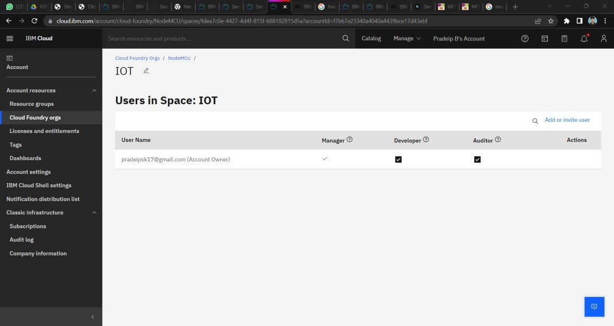

**IBM WATSON IOT PLATFORM:**

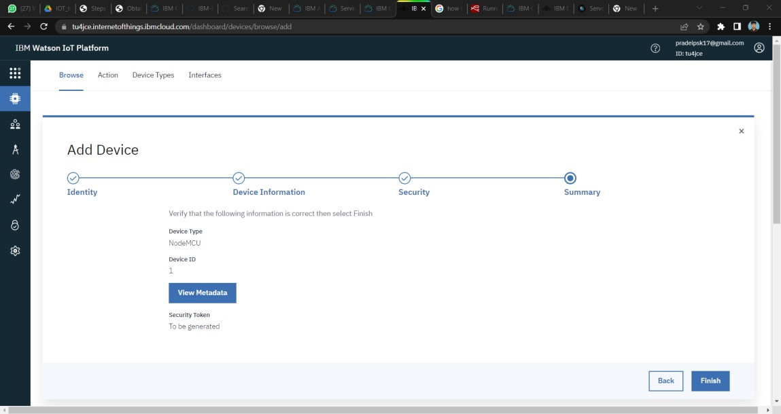

**MIT APP INVENTOR:**

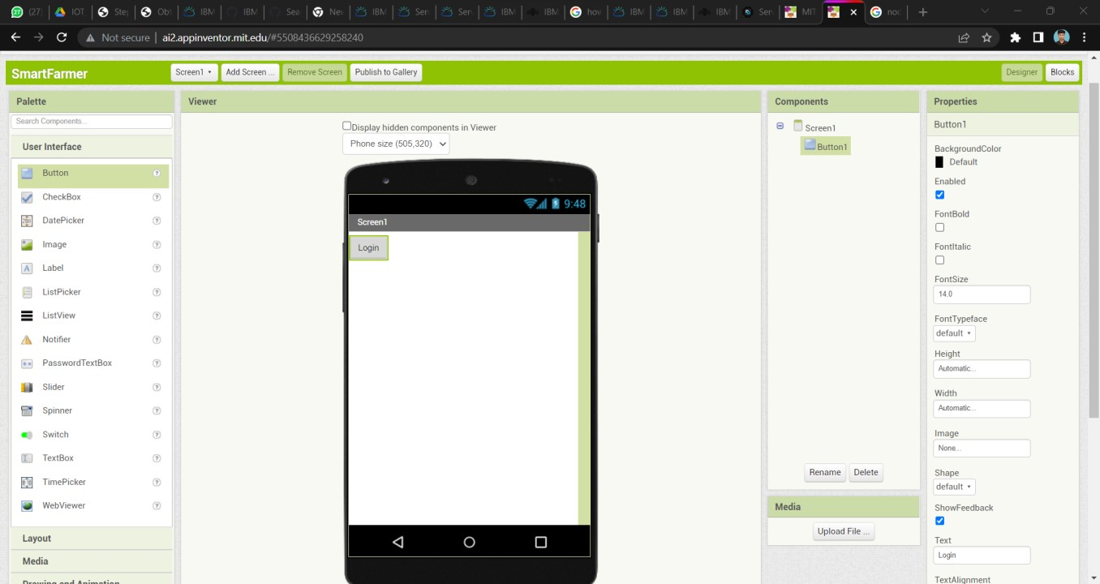

**NODE-RED:**

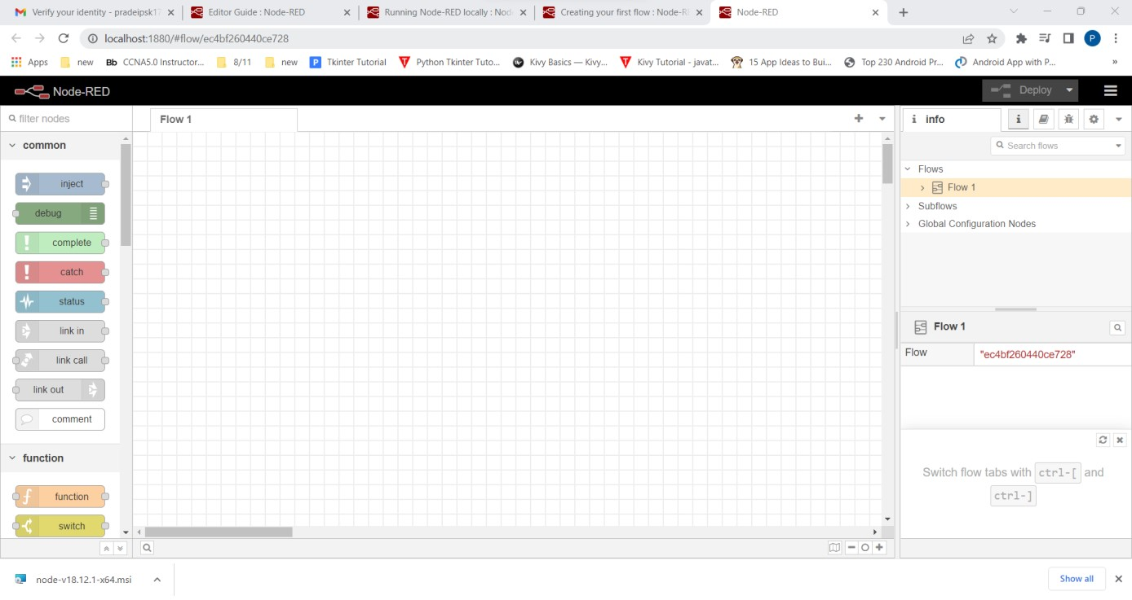

**MEASURING TEMPERATURE AND HUMIDITY VALUES WITH ESP 32:**

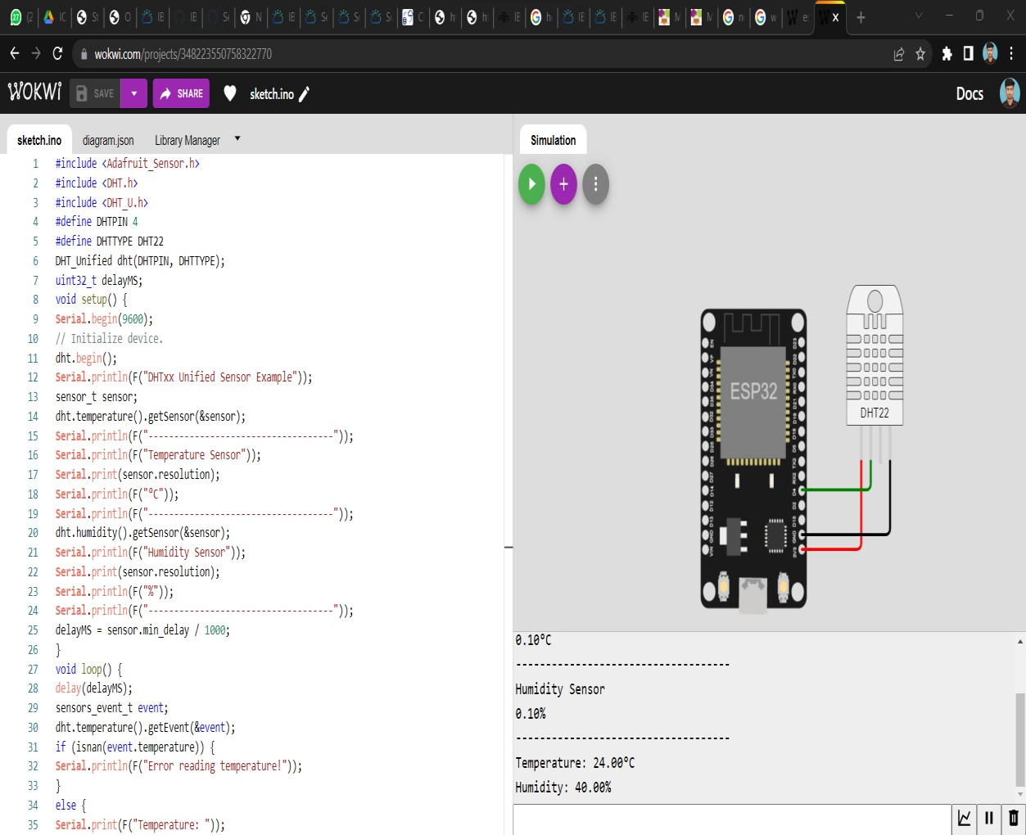

**Program:**

#include <Adafruit_Sensor.h>

#include <DHT.h>

#include <DHT_U.h>

#define DHTPIN 4

#define DHTTYPE DHT22

DHT_Unified dht(DHTPIN, DHTTYPE); uint32_t delayMS; void setup() { **Serial**.begin(9600); // Initialize device.

dht.begin();

**Serial**.println(F("DHTxx Unified Sensor Example")); sensor_t sensor;

dht.temperature().getSensor(&sensor);

**Serial**.println(F("------------------------------------"));

**Serial**.println(F("Temperature Sensor"));

**Serial**.print(sensor.resolution);

**Serial**.println(F("°C"));

**Serial**.println(F("------------------------------------")); dht.humidity().getSensor(&sensor); **Serial**.println(F("Humidity Sensor"));

**Serial**.print(sensor.resolution);

**Serial**.println(F("%"));

**Serial**.println(F("------------------------------------")); delayMS = sensor.min_delay / 1000;

} void loop() { delay(delayMS); sensors_event_t event; dht.temperature().getEvent(&event); if (isnan(event.temperature)) {

**Serial**.println(F("Error reading temperature!"));

} else {

**Serial**.print(F("Temperature: "));

**Serial**.print(event.temperature);

**Serial**.println(F("°C"));

} dht.humidity().getEvent(&event); if (isnan(event.relative_humidity)) {

**Serial**.println(F("Error reading humidity!"));

} else {

**Serial**.print(F("Humidity: "));

**Serial**.print(event.relative_humidity);

**Serial**.println(F("%"));

}

}